***Software Project Management Assignment-1***

***Chapter 1. Introduction to Software Project Management***

1. What is project? What are characteristics of the project?

* Project is a planned activity. It emphasis on how to carry out a task. The activities that benefit most from conventional project management lie between two extremes: Routine and Outcome.
* When a routine task is done for first time it is a project. On the other hand, a project to develop a system similar to previous ones that have developed will have large element of the routine.

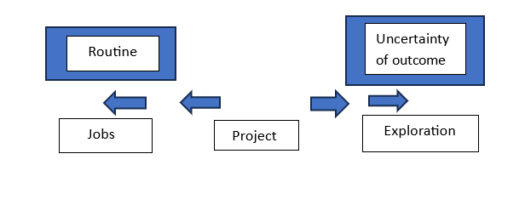

* Characteristics of Project:
* Non-routine tasks are involved.
* Planning is required.
* Specific objectives are to be met or specified product is to be created.
* The project has a predetermined time span.
* Work involves several specialisms.
* Work is carried out in several phases.
* The resources that are available for use on the project are constrained.
* People are formed into a temporary work group to carry out the task.

1. Explain with diagram software development life cycle.

* The activities in the software development life cycle are as follows:

1. Requirement Analysis

It starts with requirement elicitation or requirement gathering which establishes what potential users & their managers require of the new system.

1. Architecture Design

The components of new system that fulfil each requirement have to be identified. These components could be software, hardware or work process.

1. Detailed Design

Each software component is made of a number of software units can be separately coded & tested. The detailed design of these units is carried out separately.

1. Code & Test

It refers to writing code for each software unit. Initial testing to debug individual software units would be carried out at this stage.

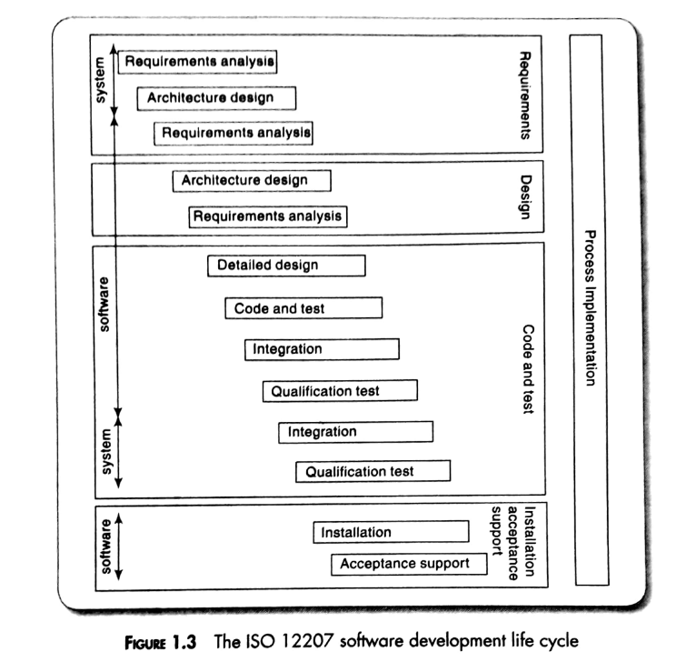

1. Integration

The components are tested together to see if they meet overall requirement. Integration could involve combining different software components or combining & testing software element of system in conjunction with hardware platforms & user interaction.

1. Qualified Testing

The system including the software components, has to be tested carefully to ensure that all requirements are fulfilled.

1. Installation

This is the process of making the new system operational. It includes activities such as setting up standing data, setting system parameters, installing hardware software into hardware platforms & user training.

1. Acceptance Support

This is resolving of problems with newly installed system, including correction of many errors & implementing agreed extensions & improvements.

1. What is management? Which are the various management activities?

Management involves setting objectives for a system and then monitoring the performance of the system. It has been suggested that management involves the following activities:

1. Planning- It is deciding what is to be done.
2. Organizing- It means making arrangements.
3. Staffing- Selecting the right people for the job, etc.
4. Directing- It means giving instructions.
5. Monitoring- It means checking on the progress.
6. Controlling- It means taking actions to remedy hold-ups.
7. Innovating- It means coming up with new solutions.
8. Representing- It means liaising with clients, users, developers, suppliers and other stakeholders.
9. Who are stakeholders in a software development?

These are people who have a stake or interest in the project. Their early identification is important as you need to set up adequate communication channels with them. Stakeholders can be categorized as:

• Internal to the project team This means that they will be under the direct managerial control of the project leader.

• External to the project team but within the same organization For example, the project leader might need the assistance of the users to carry out systems testing. Here the commitment of the people involved has to be negotiated.

• External to both the project team and the organization External stakeholders may be customers (or users) who will benefit from the system that the project implements. They may be contractors who will carry out work for the project. The relationship here is usually based on a contract.

Different types of stakeholders may have different objectives and one of the jobs of the project leader is to recognize these different interests and to be able to reconcile them. For example, end-users may be concerned with the ease of use of the new application, while their managers may be more focused on staff savings. The project leader therefore needs to be a good communicator and negotiator. Boehm and Ross proposed a 'Theory W' of software project management where the manager concentrates on creating situation where all parties benefit from a project and therefore have an interest in its success. (The 'W' stands for 'win-win'.)

Project managers can sometimes miss an important stakeholder group, especially in unfamiliar business contexts. These could be departments supplying important services that are taken for granted.

Given the importance of coordinating the efforts of stakeholders, the recommended practice is for a communication plan to be created at the start of a project.

1. Explain W5HH principles Barry Boehm.

WSHH Principle: Boehm suggested that during project initiation, the project champions should have comprehensive answers to a set of key questions pertaining to the project. The answers to these questions would lead to the definition of key project characteristics. The name of this principle (WSHH) is an acronym constructed from the first letter of each question. This set of seven questions is the following:

• Why is the software being built?

• What will be done?

. When will it be done?

• Who is responsible for a fiction?

• Where are they organizationally located?

• How will the job be done technically and managerially?

• How much of each resource is needed?

1. State and explain principle project management processes.

Project management involves a set of processes that help plan, execute, control, and close a project efficiently. The Project Management Institute (PMI) outlines five principle project management processes within its Project Management Body of Knowledge (PMBOK). Here they are, along with explanations for each:

1. Initiating Process Group:

- Process: Initiating

- Explanation: This process group involves defining and authorizing the project or project phase. It includes activities such as identifying stakeholders, understanding their needs and expectations, and clarifying the project's objectives. The main output of this group is the project charter, which formally initiates the project and gives the project manager the authority to proceed.

2. Planning Process Group:

- Processes: Planning, Scope Management, Time Management, Cost Management, Quality Management, Human Resource Management, Communication Management, Risk Management, Procurement Management, Stakeholder Management

- Explanation: The planning process group involves creating a comprehensive plan that guides the project execution. It includes defining the project scope, creating a project schedule, estimating costs, determining quality standards, allocating resources, identifying risks, and establishing communication and procurement strategies. The output of this group is the project management plan.

3. Executing Process Group:

- Processes: Direct and Manage Project Work, Perform Quality Assurance, Acquire Resources, Develop Team, Manage Team, Manage Communications, Conduct Procurements, Manage Stakeholder Engagement

- Explanation: This process group involves putting the project management plan into action. It includes coordinating and managing resources, communicating with stakeholders, and performing quality assurance. The goal is to accomplish the project's objectives as outlined in the project management plan.

4. Monitoring and Controlling Process Group:

- Processes: Monitor and Control Project Work, Perform Integrated Change Control, Validate Scope, Control Scope, Control Schedule, Control Costs, Control Quality, Control Communications, Control Risks, Control Procurements, Monitor Stakeholder Engagement

- Explanation: The monitoring and controlling process group focuses on tracking and measuring project performance against the project management plan. It involves identifying and addressing any deviations, changes, or issues that arise during project execution. This group ensures that the project stays on track and meets its objectives.

5. Closing Process Group:

- Process: Close Project or Phase

- Explanation: The closing process group involves finalizing all activities across all project management process groups to formally close the project or project phase. It includes tasks such as obtaining final acceptance from stakeholders, completing all documentation, releasing resources, and archiving project records. The outcome is the successful conclusion of the project and the transition to ongoing operations or the next project phase.

These principle project management processes provide a structured framework for managing projects from start to finish, helping ensure successful outcomes and efficient resource utilization. Each process group interacts with the others throughout the project lifecycle, creating a continuous cycle of planning, execution, monitoring, controlling, and closing.

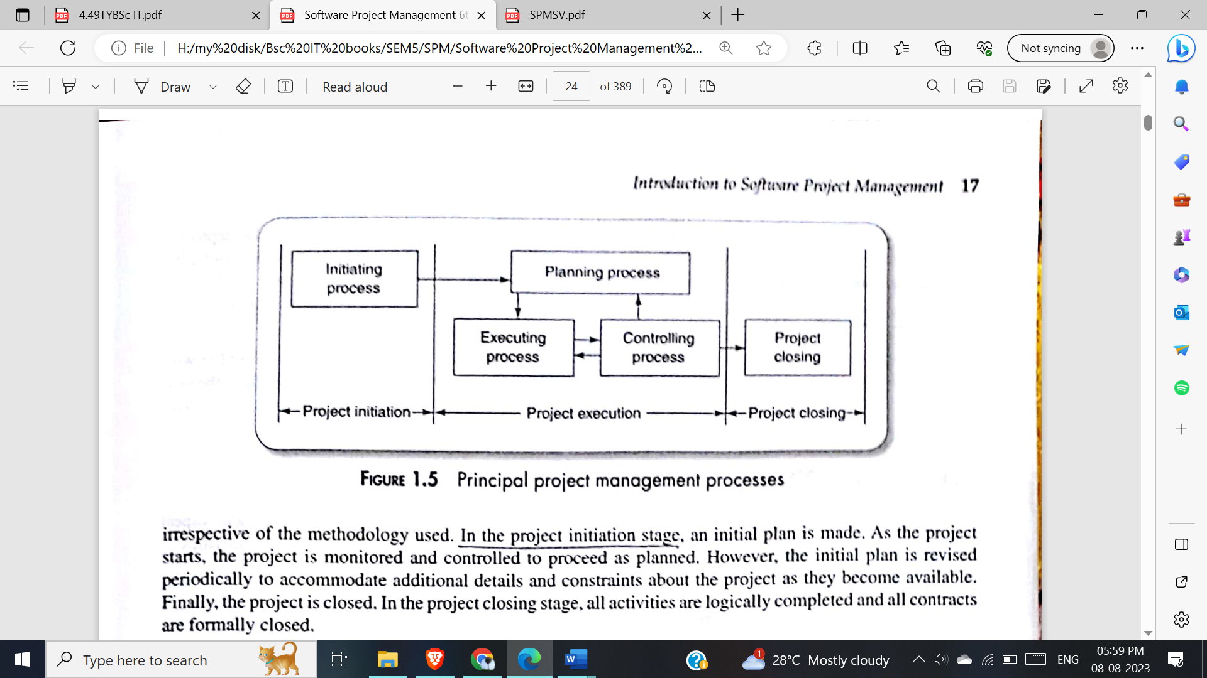

***Chapter 2- Project Evaluation and programme management***

**Q . What is Project portfolio management? Explain the key aspects of Project**

**portfolio management.**

Ans:

Definition: Portfolio project management provides an overview of all projects that an organization is undertaking or is considering. It prioritizes the allocation of resources to projects and decides which new projects should be accepted and which existing should be dropped.

The concerns of project portfolio management include:

• Evaluating proposals for projects

• Assessing the risk involved with projects

• Deciding how to share resources between projects

• Taking account of dependencies between projects

• Removing duplication between projects

• Ensuring necessary developments have not been inadvertently been missed

There are three elements to Project Portfolio Management:

1. Project portfolio definition

– Create a central record of all projects within an organization

– Must decide whether to have ALL projects in the repository or, say, only ICT projects

– Note difference between new product development (NPD) projects and renewal

projects for process improvement

2. Project portfolio management

-Actual costing and performance of projects can be recorded and assessed and this information can be basis for the more rigorous screening of new project.

3. Project portfolio optimization

Information gathered is tracked and used achieve better balance of projects e.g. some

that are risky but potentially very valuable balanced by less risky but less valuable projects.

Problems with project portfolio management 1. Poor project prioritization: Failing to prioritize projects effectively can result in valuable resources being allocated to low-priority or non-strategic projects, while high-priority initiatives suffer.

2. Resource constraints: Allocating resources across multiple projects can be a complex task, especially when resources are limited. Conflicts may arise when projects compete for the same resources, leading to delays and compromised project outcomes.

**Q .How the feasibility of an individual project can be evaluated ?**

Ans:

feasibility of an individual project can be evaluated in following ways:

* Technical assessment
* Cost-benefit analysis
* Cash flow forecasting

Technical assessment

* Technical assessment of a proposed system consists of evaluating whether the required functionality can be achieved with current affordable technologies.
* Organizational policy, aimed at providing a consistent hardware/software infrastructure is likely limit the technical solutions considered.
* The cost of the technology adopted must be taken into account in the cost-benefit analysis.

Cost-benefit analysis

* A cost-benefit analysis compares the expected costs of the project against the anticipated benefits or returns.
* Cost-benefit analysis comprises 2 steps:-

- Identifying all the cost like development costs, operating costs and benefits of carrying out the project and operating the operating the delivered application.

- Expressing these costs and benefits in common units. Express each cost and benefit and net benefit

* Most direct costs are categorized as:

-Development cost ,including development staff costs.

-Setup costs, consisting of the costs of putting the system into place mainly of new hardware but also including the costs of file conversion, recruitment and staff training.

-Operational costs relating to the system after installation.

Cash flow forecasting

* Cash flow forecasting involves predicting the inflow and outflow of cash throughout the project's life cycle.
* Accurate cash flow forecasting is difficult as it is done early in the project’s life cycle and many items to be estimated might be some years in the future.
* When estimating future cash flows it is usual to ignore the effects of inflation. Forecasts of inflation rates tend to be uncertain.

**Q .List and Define Cost-benefit evaluation Techniques**

Ans:

Cost-benefit evaluation Techniques:

1.Net Profit

2.Payback period

3.Net present value

4.Return on investment (ROI)

5.Internal rate of return

Net Profit:

* The net profit is the difference between the total costs and the income over the life of the project.

Payback period:

* The payback period is the time taken to break even or pay back initial investment. Normally the project with the shortest payback period will be chosen on the basis that an organization will wish to minimize the time that a project is ‘in debt’
* It is easy to calculate and not sensitive to small forecasting errors as the same time disadvantage is it ignore overall profitability of the project.

Net present value:

* It is the technique that takes into account the profitability of a project and the timing of the cash flows that are produced.
* NPV for a project is obtained by discounting each cash flow (both negative and summing the discounted values.

Return on investment:

* Also known as accounting rate of return (ARR), provides a way of comparing the net profitability to the investment required.
* Formula for calculating ROI:

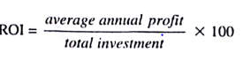

Internal rate of return:

* Internal rate of return (IRR) is the discount rate that would produce an NPV of 0 for the project. It can be used to compare different investment opportunities. There is a Microsoft Excel function which can be used to calculate

**Q. Explain different approaches to Risk Evaluation.**

Ans:

Business risks occur when the delivered products are not profitable. It is important to evaluate such risks for project’s success. Different approaches to Risk Evaluation are as follows:

1. Risk identification and ranking
2. In any project evaluation, the risks should be identified and their effects should be quantified.
3. One approach is to construct a project risk matrix utilizing a checklist of possible risks and classifying risks according to their relative importance and likelihood.
4. The project risk matrix may be used as way of evaluating projects or as a means of identifying and ranking the risks for a specific project.
5. Risk and net present value
6. Projects may be categorized as high, medium, or low risk using a scoring method and risk premiums designated for each category.
7. The premiums, even if arbitrary, provide a consistent method of taking risk into account.
8. Cost Benefit analysis
9. A more sophisticated approach to the evaluation of risk is to consider each possible outcome and estimate the probability of its occurring and the corresponding value of the outcome.
10. This approach is frequently used to evaluate larger projects. For, single major project, the cost benefit approach, by ‘averaging out’ the negative and positive outcomes of the different scenarios, does not take full account of worst-case scenarios.
11. Risk profile analysis
12. An approach which attempts to overcome some of the objections to cost-benefit averaging is the construction of risk profiles using sensitivity analysis.
13. By studying the results of a sensitivity analysis, factors that are most important to the success of the project can be identified.
14. Then it should be decided whether those can be exercised with greater control or their effects can be mitigated, if neither is the case, the project needs to live with the risk or the project should be abandoned.
15. Using decision trees
16. Decisions like whether a risk is important and, if it is, deciding a suitable course of action will limit or affect future options and, at any point, it is important to be able to assess how a decision will affect the future profitability of the project.
17. The scenarios of decision making can be represented as a tree structure.
18. The analysis of a decision tree consists of evaluating the expected benefit of taking each path from a decision point.

**SPM CHAPTER 3**

**Q1. Outline the general approach that might be taken for project planning in an organized step-by-step manner with the help of a diagram.**

**ANS:**

1. Step Wise method aims to introduce standardization of the project planning method brought by PRINCE.  
   A major principle of project planning is to plan in outline first and then in more detail as the time to carry out an activity approaches. Hence the lists of products and activities that are the result of Step 4 will be reviewed
2. The various steps involved are
   1. Step 0 - Select project: There must be some process by which the project to be executed was selected.
   2. Step 1. Identify project objectives: It is important that at the outset the main stakeholders are all aware of the precise objectives of the project.
   3. Step 2. Identify project infrastructure: This may not be a significant step where you are working on an in-house project in a very familiar environment.
   4. Step 3. Analyse project characteristics: Different types of projects will need different technical and management approaches. For example, a project to implement control software embedded in industrial equipment will need a different set of methods than a project to implement a business information system. A multimedia application would again need a different set of activities.
   5. Step 4. Identify products and activities: With software projects, it is best to start by listing the products, both deliverable and intermediate, to be created. The activities needed to create the products can then be identified
   6. Step 5. Estimate effort for activity.
   7. Step 6. Identify activity risks: Having assessed the amount of effort and the elapsed time for a project, the reasons why these might vary during the actual execution of the project need to be considered. Where there is a very high risk of additional effort/time being needed then actions to reduce this risk may be formulated.
   8. Step 7. Allocate resources: With software projects, these resources will mainly be staff but could be equipment etc.
   9. Step 8. Review/publicize: It is no good having a plan if no one knows about it.
   10. Step 9. Execute Plan.
   11. Step 10. Lower level planning: Not all of a project, especially when it is large, can be planned in detail at the outset. Not all the information needed to plan the later stages will be available at the beginning.

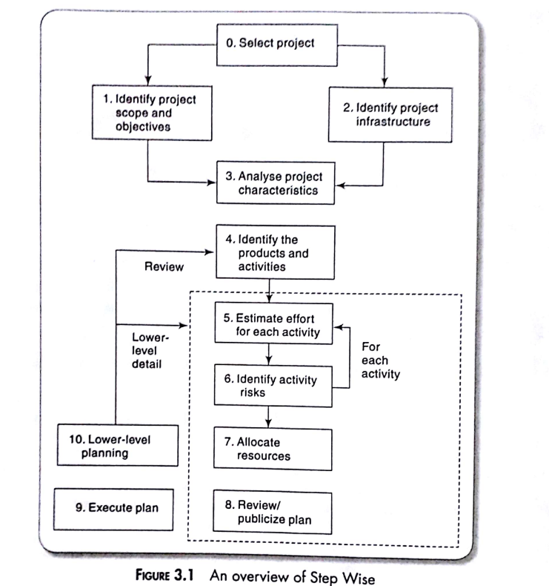

**Q2. Describe the Product Breakdown Structure with the help of a diagram.**

**Ans:**

1. Identifying all the things the project is to create helps us to ensure that all the activities we need to carry out are accounted for.
2. These products will include a large number of intermediate products such as technical products, management products, etc. Products also include deliverables that are delivered to clients.
3. The products will form a hierarchy. The main products will have sets of component products which in turn may have sub-component products, and so on. These relationships can be documented in a Product Breakdown Structure (PBS).
4. A product could quite easily be a document, such as a software design document, or a version of something that already exists, such as an amended piece of code.
5. Products could even be a person, such as a 'trained user', a product of the process of training. A product is the result of an activity.
6. A common error is to identify as products things that are really activities, such as 'training', 'design', and 'testing'.
7. This part of the planning process draws heavily on the standards laid down in PRINCE2. These specify that products at the bottom of the PBS should be documented by Product Descriptions which contain:
   1. Name/identity of the product
   2. Purpose of the product
   3. Derivation of the product (that is, the other products from which it is derived)
   4. Composition of the product
   5. Form of the product
   6. Relevant standards
   7. Quality criteria that define whether the product is acceptable

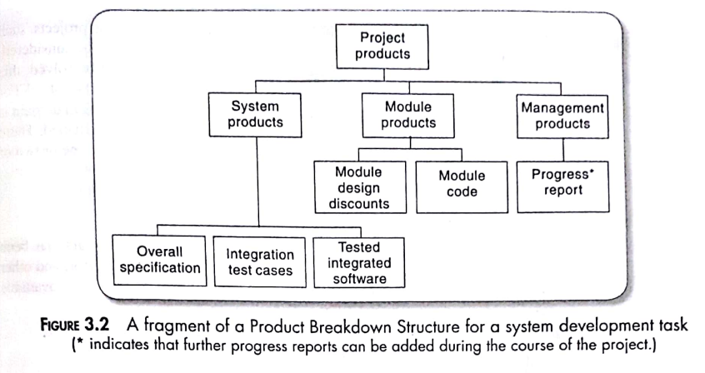

**Q3. Explain the Product Flow Diagram with an example.**

**Ans:**

1. A Product Flow Diagram (PFD) illustrates the sequence of work or activities and the flow of deliverables through the various phases of a project.
2. It helps visualize how different components are connected and how work progresses from one stage to another.
3. The relationship between one or many products can be shown using the product flow diagram. For eg:program design must exist before the design can be started.
4. PFDs should not have links between products which loop back iteratively. This is emphatically not because iterations are not recognized.
5. On the contrary, the PFD allows for looping back at any point.
6. say that during Integration testing It was found out that a user requirement has been missed in the overall system specification. If we go back to overall system specification and change it we can see from the PFD that all the products that follow it might need to be reworked. A new module might need to be designed and coded, test cases would need to be added to check that the new requirements had been successfully incorporated, and the integration testing would need to be repeated.
7. The form that a PFD takes will depend on assumptions and decisions about how the project is to be carried out.
8. These decisions may not be obvious from the PFD and so a textual description explaining the reasons for the structure can be helpful.

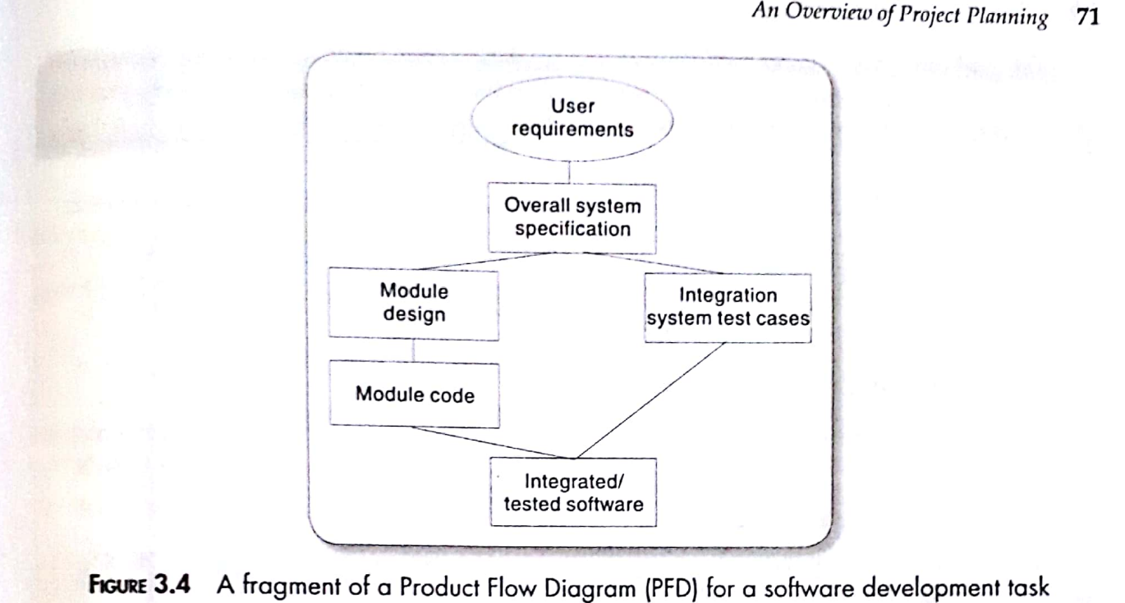

**Q4.What products must exist before the ‘test program’ activity? What products does this activity produce?**

**Ans:-**

Before the "test program" activity, several products or artifacts should already exist to ensure a smooth and effective testing process.

These products help lay the groundwork for testing efforts and ensure that testing can be executed systematically

Before 'Test Program' Activity

1. Test Strategy/Plan: High-level testing approach, scope, and objectives.

2. Requirements Documentation: Detailed project requirements.

3. Test Cases: Detailed scenarios and expected outcomes.

4. Test Data: Inputs for effective test execution.

5. Test Environment: Stable environment mimicking production.

6. Test Automation Code: Automation scripts if used.

7. Defect Tracking System: Issue tracking system.

Products Produced by 'Test Program' Activity:

1. Test Results: Outcomes of each test case.

2. Defect Reports: Documented issues.

3. Test Logs: Records of testing activities.

4. Test Summary Report: High-level testing outcomes.

5. Updated Test Cases: Adjusted test cases.

6. Lessons Learned: Insights from testing process.

**Q5. Brightmouth College wants to automate the routine activities of Its library including issuing books, return of books, managing fine collections, and querying the availability of books. The library has around 10,000 books. At present, the activities of the library are being carried out manually by the four-member library staff. The college intends to allot the development of the software to a vendor. The software would have to be transferred to the library in a fully operational mode. To speed up the delivery of software, the vendor would have to create the operational database during the development of the software. This would involve entering details of the existing books into a CSV (comma-separated values) file. After the development of the software, the CSV data will have to be imported into the software. After alpha testing, the software would have to be tested in the operational environment. For this, the software would have to be run alongside the manual system at the library for a week. During**

**this time, user training would also have to be conducted.**

**(a) Identify and represent the deliverables using a product breakdown structure (PBS)**

**(b) Develop the product flow diagram**

**(c) Develop an activity network**

**Ans:**

**Project Breakdown Structure**

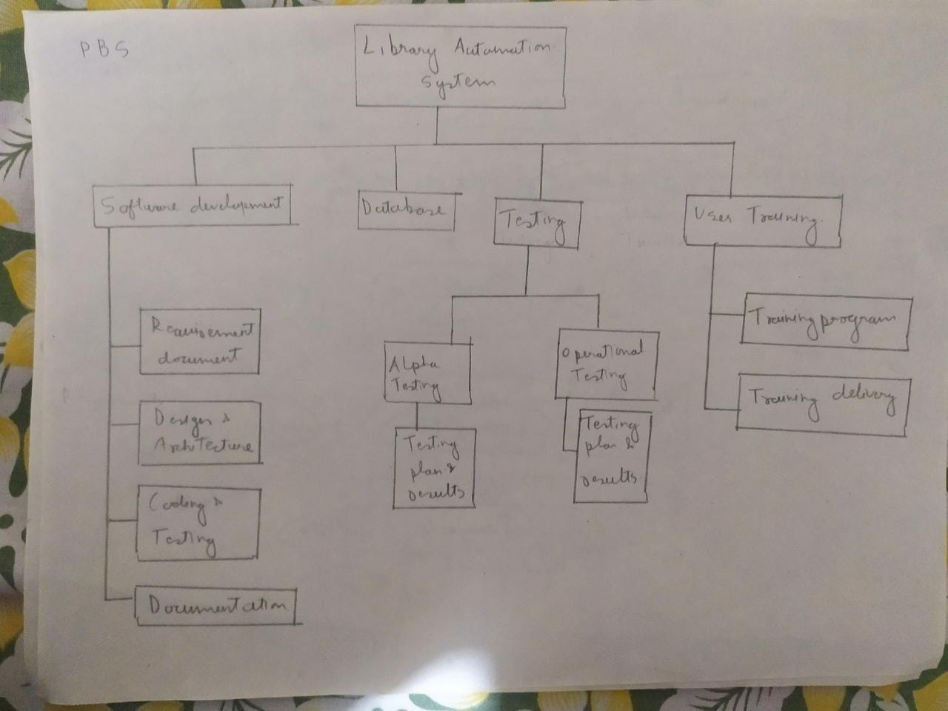

**PFD**

**Product Flow Diagram**

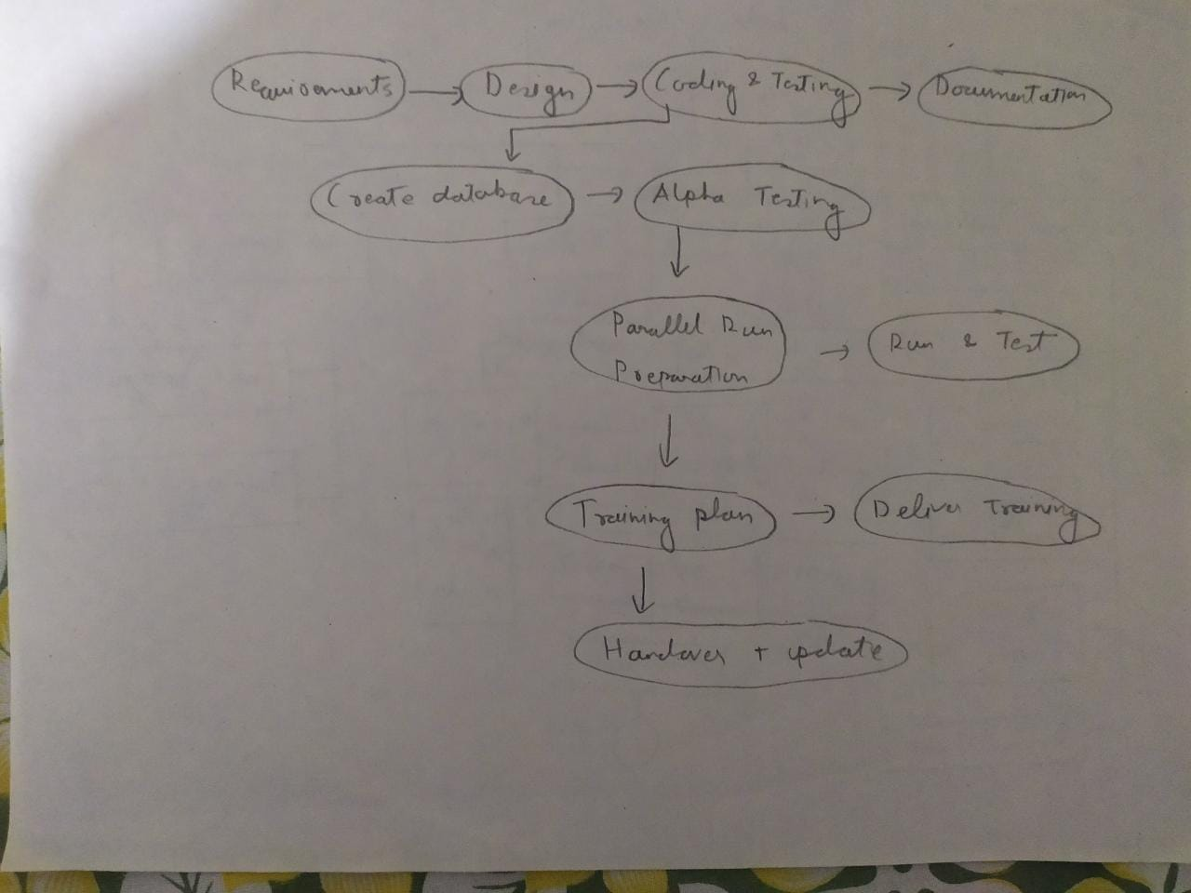

**Acitivity network or PERT(program evaluation and review technique)**

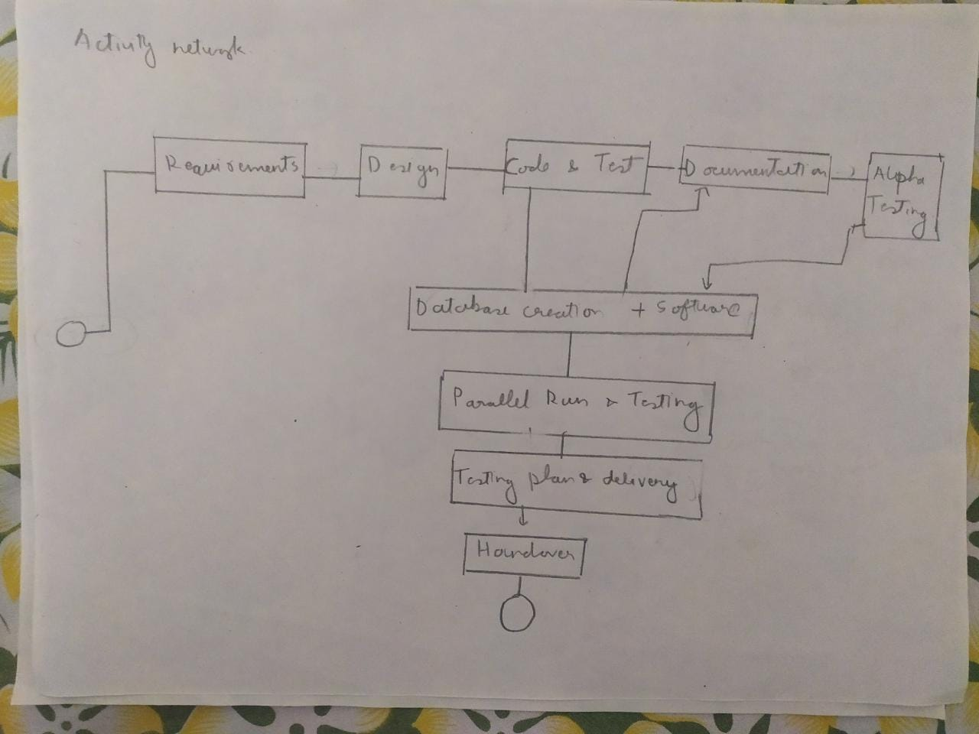

**PBS**

**Library Automation Project**

**|-- Software Development**

**| |-- Requirements Gathering**

**| |-- Design and Architecture**

**| |-- Coding and Testing**

**| |-- Documentation**

**|**

**|-- Operational Database Creation**

**| |-- CSV Data Entry**

**| |-- Import into Software**

**|**

**|-- Alpha Testing**

**| |-- Testing Plan**

**| |-- Testing Execution**

**|**

**|-- Operational Environment Testing**

**| |-- Parallel Run Preparation**

**| |-- Parallel Run and Testing**

**|**

**|-- User Training**

**| |-- Training Plan**

**| |-- Training Delivery**

**|**

**|-- Project Closure**

**| |-- Handover to Library**

**| |-- Documentation Update**

**PFD**

**Requirements Gathering --> Design and Architecture --> Coding and Testing --> Documentation**

**^ |**

**| |**

**| v**

**CSV Data Entry + Import into Software --> Alpha Testing**

**|**

**v**

**Parallel Run Preparation --> Parallel Run and Testing**

**|**

**v**

**Training Plan --> Training Delivery**

**|**

**v**

**Handover to Library + Documentation Update**

**ACTIVITY NETWORK**

**Start**

**|**

**v**

**Requirements Gathering --> Design and Architecture --> Coding and Testing --> Documentation --> Alpha Testing**

**| ^ |**

**| | v**

**+-> CSV Data Entry + Import into Software --> Parallel Run Preparation --> Parallel Run and Testing**

**| |**

**+---------------------------------------------> Training Plan --> Training Delivery**

**|**

**+-----------------------------------------------> Handover to Library + Documentation Update**

**|**

**End**